MaNGA的数据，请用DR17(V3\_1\_1): https://www.sdss.org/dr17/manga/manga-data/data-access/

Data Analysis pipeline（DAP）的输出文件包括（use SPX at current stage）：

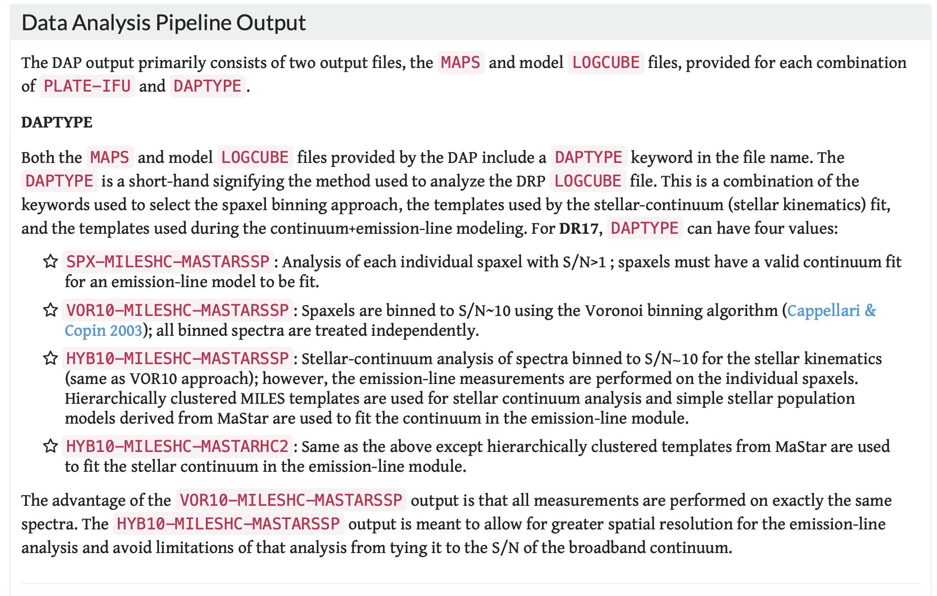

（<https://www.sdss.org/dr17/manga/manga-analysis-pipeline/#Outputs>）

每个文件里存储的参数介绍见：

[https://data.sdss.org/datamodel/files/MANGA\_SPECTRO\_ANALYSIS/DRPVER/DAPVER/DAPTYPE/PLATE/IFU/manga-MAPS-DAPTYPE.html](https://data.sdss.org/datamodel/files/MANGA_SPECTRO_ANALYSIS/DRPVER/DAPVER/DAPTYPE/PLATE/IFU/manga-MAPS-DAPTYPE.html,)

这些参数保含Stellar-continuum modeling, Emission-line Measurements & Spectral-index Measurements，e.g.，the equivalent widths are named as [EMLINE\_GEW](https://data.sdss.org/datamodel/files/MANGA_SPECTRO_ANALYSIS/DRPVER/DAPVER/DAPTYPE/PLATE/IFU/manga-MAPS-DAPTYPE.html" \l "emline_gew)， [STELLAR\_VEL](https://data.sdss.org/datamodel/files/MANGA_SPECTRO_ANALYSIS/DRPVER/DAPVER/DAPTYPE/PLATE/IFU/manga-MAPS-DAPTYPE.html" \l "stellar_vel) includes stellar velocities

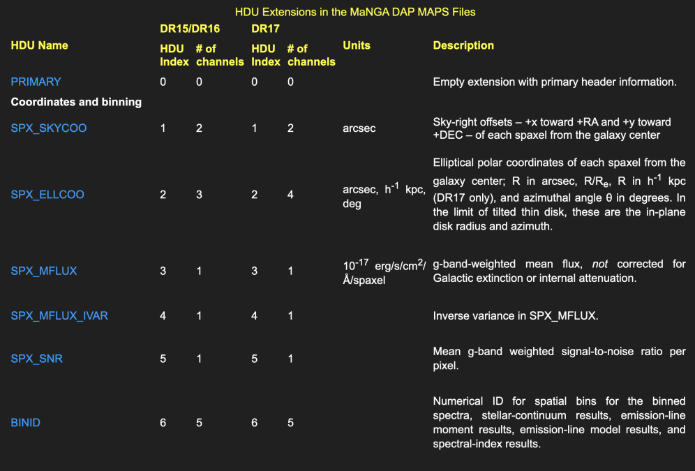

As a first step, I would like to suggest you to

1. plot all kinds for maps through python such as stellar velocity fields (maps) (traced by absorption lines in the spectra), gas velocity fields (traced by the Doppler shift of emission lines)，[OIII] 5007 EQW. The velocity maps look like

<https://sas.sdss.org/marvin/galaxy/7443-12701/> (7443-12701 is plate-ifudesign)

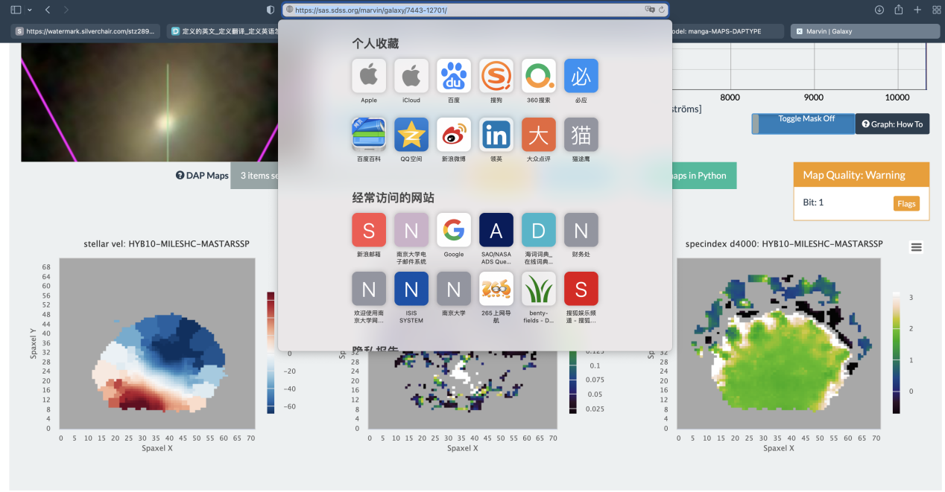

附件obvious\_bicone\_feature\_position.fits中包含了我认为bicone结构比较明显的17个源的plateifudesign，你可以画出BPT，spatial resolved BPT以及[OIII]5007 EQW maps观察下。

我让学生准备了一个python画图程序:稍后转发到你邮箱。你可以尝试从这个程序开始。

程序中的图像，你可能暂时没有，就先把相应的画图语句删除就行。

1. Read the following papers:

<http://adsabs.net/abs/2019MNRAS.490.3830B> (check how bicone looks like)

<http://adsabs.net/abs/2003MNRAS.346.1055K> (one of BPT diagram Figure1)

<http://adsabs.net/abs/2006MNRAS.372..961K> (also BPT Figure1)

再次申明，链接没有问题，如果你遇到了问题，换个电脑或者浏览器

Let me know if you finished these two steps (I would expect 2 weeks for a full time graduate student).

unique\_galsamp\_mpl11.fits: 这是一个包含了MaNGA观测所有星系基本信息（plate-ifu,ra,dec,z......）的列表